**“ QuizOrbit “**

**Second Year Mini Project Report**

Submitted in partial fulfillment of the requirements of the degree

**BACHELOR OF ENGINEERING IN COMPUTER ENGINEERING**

By

**Rishi Daryani (18)**

**Dhruv Chatrani (13)**

**Tarun Gulwani (26)**

**Yash Janyani (31)**

Supervisor

**Mrs. Pallavi Saindane**



**Department of Computer Engineering**

**Vivekanand Education Society’s Institute of Technology HAMC, Collector’s Colony, Chembur, Mumbai400074 University of Mumbai**

**(AY 202324)**

# CERTIFICATE

This is to certify that the Mini Project entitled **“ QuizOrbit ”** is a bonafide work of  **Rishi Daryani(18), Dhruv Chatrani (13), Tarun Gulwani (26), Yash Janyani(31)** submitted to the University of Mumbai in partial fulfillment of the requirement for the award of the degree of **“Bachelor of Engineering”** in **“Computer Engineering” .**

### (Prof. )

Supervisor

### (Prof.Nupur Giri) (Prof. J.M Nair)

Head of Department Principal

**Mini Project Approval**

This Mini Project entitled “ **QuizOrbit** ” by **Rishi Daryani(18), Dhruv Chatrani(13), Tarun Gulwani (26), Yash Janyani (31)** is approved for the degree of **Bachelor of Engineering in Computer Engineering.**

**Examiners**

**1………………………………………**

(Internal Examiner Name & Sign)

**2…………………………………………**

(External Examiner name & Sign)

Date:

Place:

# Contents

# Abstract i

### Acknowledgments ii

### List of Abbreviations iii

### List of Figures iv

### List of Tables v

### List of Symbols vi

### Introduction 1

* 1. Introduction
  2. Motivation
  3. Problem Statement & Objectives
  4. Organization of the Report

### Literature Survey 4

* 1. Survey of Existing System
  2. Limitation Existing system or research gap
  3. Mini Project Contribution

### Proposed System (eg New Approach of Data Summarization ) 6

* 1. Introduction
  2. Architecture/ Framework
  3. Algorithm and Process Design
  4. Details of Hardware & Software

**3.5** Experiment and Results

**3.6** Conclusion and Future work.

### References 12

**Abstract**

In the contemporary educational landscape, online platforms like QuizOrbit have emerged as invaluable resources, transforming the way young learners prepare for Olympiad MCQ examinations. This report delves into the pivotal role of QuizOrbit and the integration of innovative methods in comprehending and optimizing the quiz preparation experience for kids. The objective of this report is to offer a comprehensive insight into the applications of QuizOrbit within the realm of Olympiad MCQ exam preparation. We explore how QuizOrbit's interactive quizzes, practice tests, and performance analytics are revolutionizing the way young minds approach these competitive exams. Features like personalized quizzes and progress tracking are streamlined through advanced algorithms and data-driven insights. A fundamental aspect of this report is the examination of the interplay between adaptive learning techniques and performance analysis, pivotal in understanding the significance of QuizOrbit in terms of personalized skill development, enhanced engagement, and exam readiness. Adaptive learning techniques empower kids to focus on their weak areas, providing a tailored dimension to their exam preparation. Simultaneously, performance analysis helps in gauging their progress and areas for improvement, thereby enriching the overall exam preparation experience. The utility of adaptive learning and performance analysis extends beyond Olympiad exams, bridging the gap between traditional education and digital resources. Real-world examples showcase how QuizOrbit empowers young learners to excel in competitive exams, enabling them to build a strong foundation of knowledge and problem-solving skills.

**Acknowledgement**

We are thankful to our college Vivekanand Education Society’s Institute of Technology for considering our project and extending help at all stages needed during our work of collecting information regarding the project.

It gives us immense pleasure to express our deep and sincere gratitude to SE Mini project Coordinator Mrs. Pallavi Saindane (Project Mentor) for her kind help and valuable advice during the development of project synopsis and for her guidance and suggestions. We are deeply indebted to the Head of the Computer Department, Dr.(Mrs.) Nupur Giri and our Principal Dr. (Mrs.) J.M. Nair, for giving us this valuable opportunity to do this project. We express our hearty thanks to them for their assistance, without which it would have been difficult to finish this project synopsis and project review successfully.

We convey our deep sense of gratitude to all teaching and non-teaching staff for their constant encouragement, support and selfless help throughout the project work. It is a great pleasure to acknowledge the help and suggestion, which we received from the Department of Computer Engineering. We wish to express our profound thanks to all those who helped us in gathering information about the project. Our families too have provided moral support and encouragement several times.

**List of abbreviations:**

• SQL - Structured Query language

• HTML - Hypertext Markup Language

• CSS - Cascading Style Sheet

• JS- JavaScript

• DBMS- Database Management System

**List of Figures:**

|  |  |  |
| --- | --- | --- |
| Figure No. | Title | Page No. |
| 3.3.1 | Flowchart of the website | 9 |
| 3.5.1 | Home Page of the website | 10 |
| 3.5.2 | Subject-wise Topic Page | 10 |
| 2.5.3 | Demonstration of the quiz | 10 |
| 2.5.4 | Analysis of the Quiz | 11 |

**List of Tables:**

|  |  |  |
| --- | --- | --- |
| Table No. | Title | Page No. |
| 2.2.1 | Survey of existing systems | 4 |

**1. Introduction**

**1.1 Introduction**

This dynamic platform redefines the way students engage with educational content. Through a diverse array of video lessons spanning various subjects, students are empowered to embark on a journey of comprehensive understanding. What sets this website apart is its unique approach to knowledge reinforcement. Following each video, students are invited to delve deeper through skillfully crafted quizzes that reflect understanding of the video content. The website's capabilities extend further, illuminating the path to academic growth. With an adept tracking system, students' learning journeys are meticulously recorded, generating insightful progress reports. These personalized reports illuminate strengths and highlight areas necessitating further exploration, granting students a sense of ownership over their educational evolution. In a world where education knows no bounds, this website emerges as a cornerstone of modern learning, fusing technology and technology harmoniously.

**1.2 Motivation**

1. Interactive Learning: Quiz apps make learning more interactive and engaging. They turn passive learning into an active experience where users can test their knowledge and reinforce their understanding of various topics.

2. Gamification: Gamification elements such as scoring, leaderboards, and achievements can motivate users to participate and challenge themselves, making the learning process more enjoyable.

3. Convenience: Quiz apps are accessible on mobile devices, making it convenient for users to learn on the go. This convenience encourages users to engage with educational content at their own pace and in their preferred settings.

4. Diverse Content: Quiz apps often offer a wide range of quiz categories, catering to different interests and subjects. This variety allows users to explore new topics and expand their knowledge.

5. Personalization: Many quiz apps use algorithms to personalize the learning experience. They recommend quizzes based on a user's interests and performance, enhancing engagement.

6. Progress Tracking: Users can track their progress and see their improvement over time, which can be a motivating factor in the learning process.

7. Social Interaction: Some quiz apps allow users to compete with or challenge friends, fostering a sense of community and social interaction around learning.

**1.3 Problem Statement and Objectives**

The problem we aim to address is the lack of engaging and interactive ways for individuals to test and enhance their knowledge on a variety of subjects. Traditional methods of studying and assessing knowledge may not be as effective or enjoyable for many people, especially in a digital age where mobile applications play a significant role in education and entertainment.

Objectives:

1.Develop a Quiz App: Create a user friendly mobile application that offers a diverse range of quizzes on different topics and subjects.

2.Engagement and Motivation: Foster engagement and motivation for users to learn and test their knowledge through a gamified experience. Incorporate features such as scoring, rewards, and leaderboards to encourage participation.

3. UserCentered Design: Ensure the app is intuitive and appealing to users of all ages and backgrounds, taking into account accessibility and usability best practices.

4. Varied Quiz Categories: Provide a wide range of quiz categories to cater to diverse interests and educational needs, from general knowledge to niche subjects.

5. Question Database: Develop a substantial and well curated database of quiz questions and answers to ensure content variety and accuracy.

6. Personalized Experience: Implement algorithms that suggest quizzes tailored to the user's preferences and previous performance.

7. Progress Tracking: Allow users to track their quiz history, view correct and incorrect answers, and monitor their progress over time.

8. MultiPlatform Accessibility: Develop the app for both iOS and Android platforms to reach a broader user base.

9. Offline Access: Enable users to download quizzes for offline access, making learning more convenient.

10. Feedback Mechanism: Incorporate a feedback system to allow users to report errors, suggest improvements, and request specific quiz topics.

11. Monetization Strategy: Explore monetization options, such as in app advertisements, premium quiz packs, or a subscription model, to sustain the app's development and content creation.

12. Data Privacy and Security: Ensure the safety of user data by implementing robust security measures and abiding by privacy regulations.

13. Community Building: Create a community within the app, allowing users to discuss quizzes, share their achievements, and interact with one another.

14. Educational Value: Collaborate with educators and subject matter experts to ensure the quizzes maintain educational value and accuracy.

15. Continuous Improvement: Regularly update and expand the app with new features, quizzes, and improvements based on user feedback and emerging trends in education and technology.

**2. Literature Survey**

**2.1 Survey of Existing System**

|  |  |  |  |  |
| --- | --- | --- | --- | --- |
| **Features** | **BYJUS** | **DoubtNut** | **Vedantu** | **QuizOrbit** |
| Animated-UI | YES | YES | YES | YES |
| Adaptibility | YES | YES | YES | YES |
| Interactivity | NO | YES | NO | YES |
| Time-Constraints | YES | NO | NO | YES |

**Table 2.1.1 -** We offer Animated UI, modern User Experience and Adaptibility for users that lack in other similiar websites

**Users of the system:**

QuizOrbit is designed to cater to a broad audience, including students of all ages, educators, parents and lifelong learners. The system accommodates users seeking knowledge across various subjects and disciplines.

**2.2 Limitation Existing system or research gap**

Existing quiz based apps may have several limitations that can impact the user experience and their overall effectiveness. Some common limitations include:

1. Limited Content Variety: Many quiz apps have a limited selection of topics and questions, which can lead to user boredom and reduced engagement.

2. Question Quality: Some apps may have poorly researched or inaccurate questions, which can misinform users and hinder their learning experience.

3. Lack of Personalization: While some apps use algorithms to personalize the experience, others do not, leading to a one size fits all approach that may not suit individual learning needs and preferences.

4. Intrusive Ads: Overuse of advertisements can disrupt the user experience and lead to frustration. Users may also be discouraged by in app purchases and advertising heavy freemium models.

5. Limited Offline Access: Not all quiz apps allow users to download content for offline access, making them inaccessible in areas with poor internet connectivity.

6. Inadequate Feedback: Some apps may lack detailed feedback on incorrect answers, missing the opportunity for users to learn from their mistakes.

7. Privacy Concerns: Inadequate data privacy and security measures can discourage users concerned about the safety of their personal information.

8. Overemphasis on Speed: Timed quizzes, while engaging, may not suit all learning styles and can lead to stress and inaccuracies in answers.

9. Lack of Collaboration: Many quiz apps focus on individual learning, missing opportunities for collaborative or group learning experiences.

10. Content Outdatedness: Apps may not update their question databases regularly, leading to outdated information, particularly in fast changing fields.

11. Limited Educational Value: Some quiz apps prioritize entertainment over education, reducing their effectiveness as a learning tool.

12. Usability Issues: Poor app design, navigation, or lack of accessibility features can lead to a frustrating user experience.

**2.3 Mini Project Contribution**

**1. Scope and Objectives:**

* Help children to self-learn in gamify way
* Help Parents let them child spend good screen time

**2. Technology Stack:**

* HTML
* CSS – SASS, Tailwind css
* React Js- JavaScript
* Firebase

**3. Quiz Creation:**

* Create an intuitive interface for administrators to add questions, answers, and multimedia elements.
* Implement validation to ensure the accuracy and quality of quiz content.

**4. User Registration and Authentication:**

* Develop a secure registration and login system.
* Use encryption for password storage.
* Provide options for password recovery and profile management.

**5. Quiz Taking and Scoring:**

* Design a user-friendly interface for selecting and taking quizzes.
* Implement scoring mechanisms and time tracking features.
* Display results and correct answers at the end of each quiz.

**3. Proposed System**

**3.1 Introduction**

In the ever evolving landscape of education, an innovative online platform emerges as a beacon of modern learning – a website that seamlessly melds video instruction, interactive quizzes, and personalized progress tracking. This dynamic platform redefines the way students engage with educational content. Through a diverse array of video lessons spanning various subjects, students are empowered to embark on a journey of comprehensive understanding. What sets this website apart is its unique approach to knowledge reinforcement. Following each video, students are invited to delve deeper through skillfully crafted quizzes that mirror the video content. The website's capabilities extend further, illuminating the path to academic growth. With an adept tracking system, students' learning journeys are meticulously recorded, generating insightful progress reports. These personalized reports illuminate strengths and highlight areas necessitating further exploration, granting students a sense of ownership over their educational evolution. In a world where education knows no bounds, this website emerges as a cornerstone of modern learning, fusing technology and pedagogy harmoniously. As the virtual realm of education continues to flourish.

**3.2 Architecture/ Framework**

The architecture and framework of the student event notification app are designed to provide users with a seamless and intuitive experience for event discovery, registration, and participation. The following points outline the key components and functionalities within this architecture:

1. User Authentication and Profile Management:

* Authentication module handles user registration and login.
* User profiles store essential details and optional additional information for a personalized experience.

2. Event Data Management:

* Event data storage manages information related to events, including date, time, location, description, and participating colleges.
* Database supports efficient querying and retrieval of events based on various filters like event type, date, and location.

3. Event Presentation and Interaction:

* Frontend displays the homepage with featured and upcoming events, utilizing filters and scroll features for event exploration. Dedicated event pages provide detailed event information and registration options for users.

4. Event Registration and Notification:

* Event registration system processes user registrations for events and facilitates confirmation or additional details submission based on event organizer preferences.
* Realtime notification system ensures users receive event reminders through the website and email.

5. User Interaction and Engagement:

* User interaction modules manage user engagement, allowing feedback submission, ratings, and interaction with other attendees.
* Discussion forums and comment sections facilitate interactions between users related to specific events.

6. Recommendation Engine:

* Recommendation engine utilizes user preferences and past interactions to suggest personalized event recommendations.
* Machine learning algorithms help enhance the relevance and accuracy of event recommendations.

7. Account Security and Access Control:

* Security module ensures account security by managing user sessions, access control, and secure logout functionalities.
* Encrypted communication protocols enhance data security during user interactions.

8. Event Contribution and Feedback:

* Optional event contribution module allows users to submit event listings, contributing to a diverse event portfolio.
* Feedback and support module gathers user feedback and suggestions to enhance the platform's usability and user experience.

By integrating these architectural components, the app offers a structured and user-friendly platform for students to engage with events, encouraging seamless event discovery, easy registration, and meaningful participation. The architecture emphasizes user centric design and efficient data management to deliver a robust and enjoyable experience.

**3.3 Algorithm and Process Design**

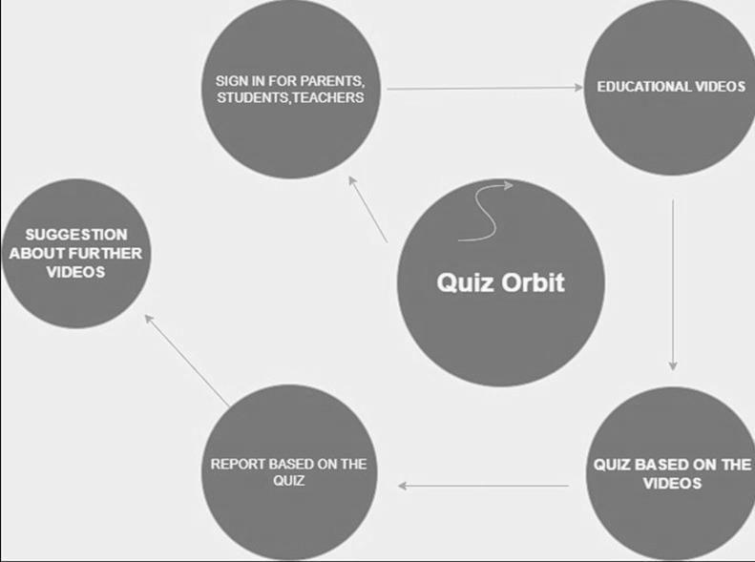

**Figure 3.3.1 -** Above figure addresses the flow of the website

**3.4 Details of Hardware & Software**

* React Js
* HTML, CSS
* Web browser
* Web connectivity
* FireBase
* Device

**3.5 Experiment and Results**

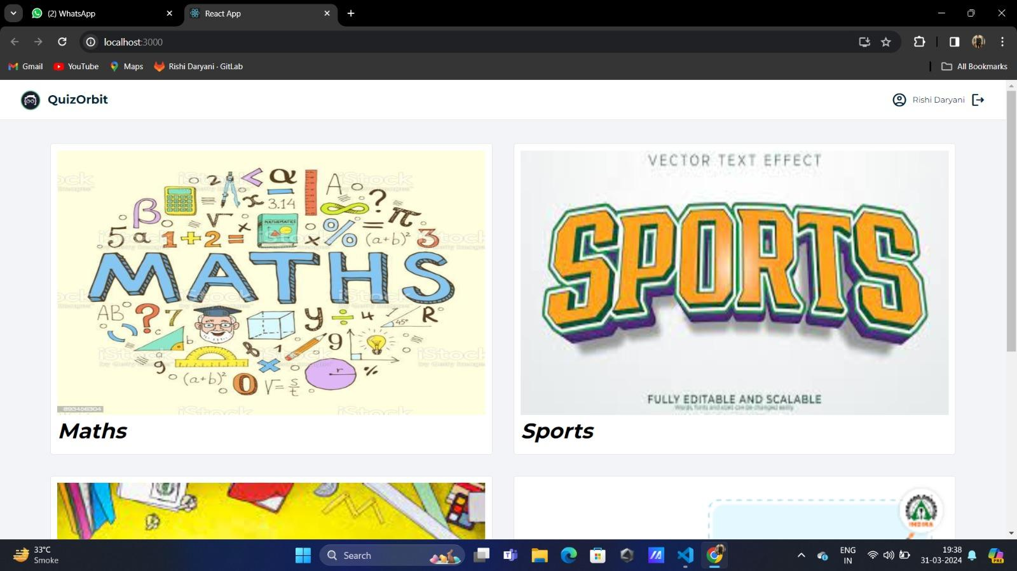

**Figure 3.5.1 -** The Home Page for the selection of the subject

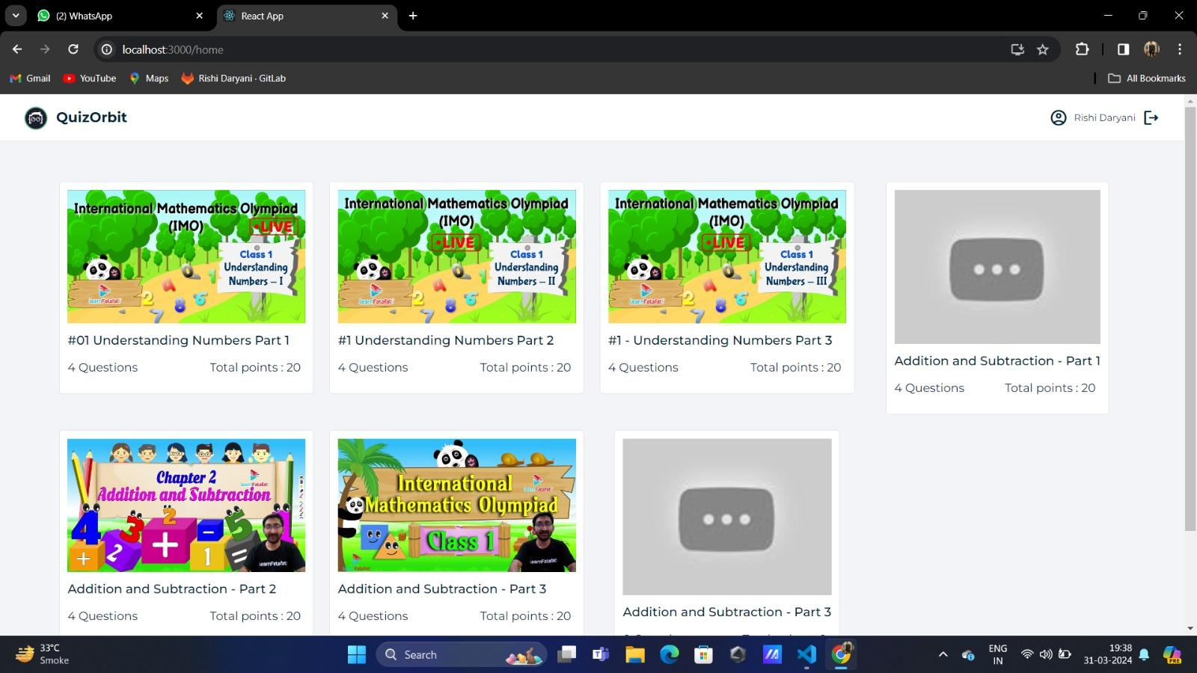

**Figure 3.5.2 -** Videos for the selected subject

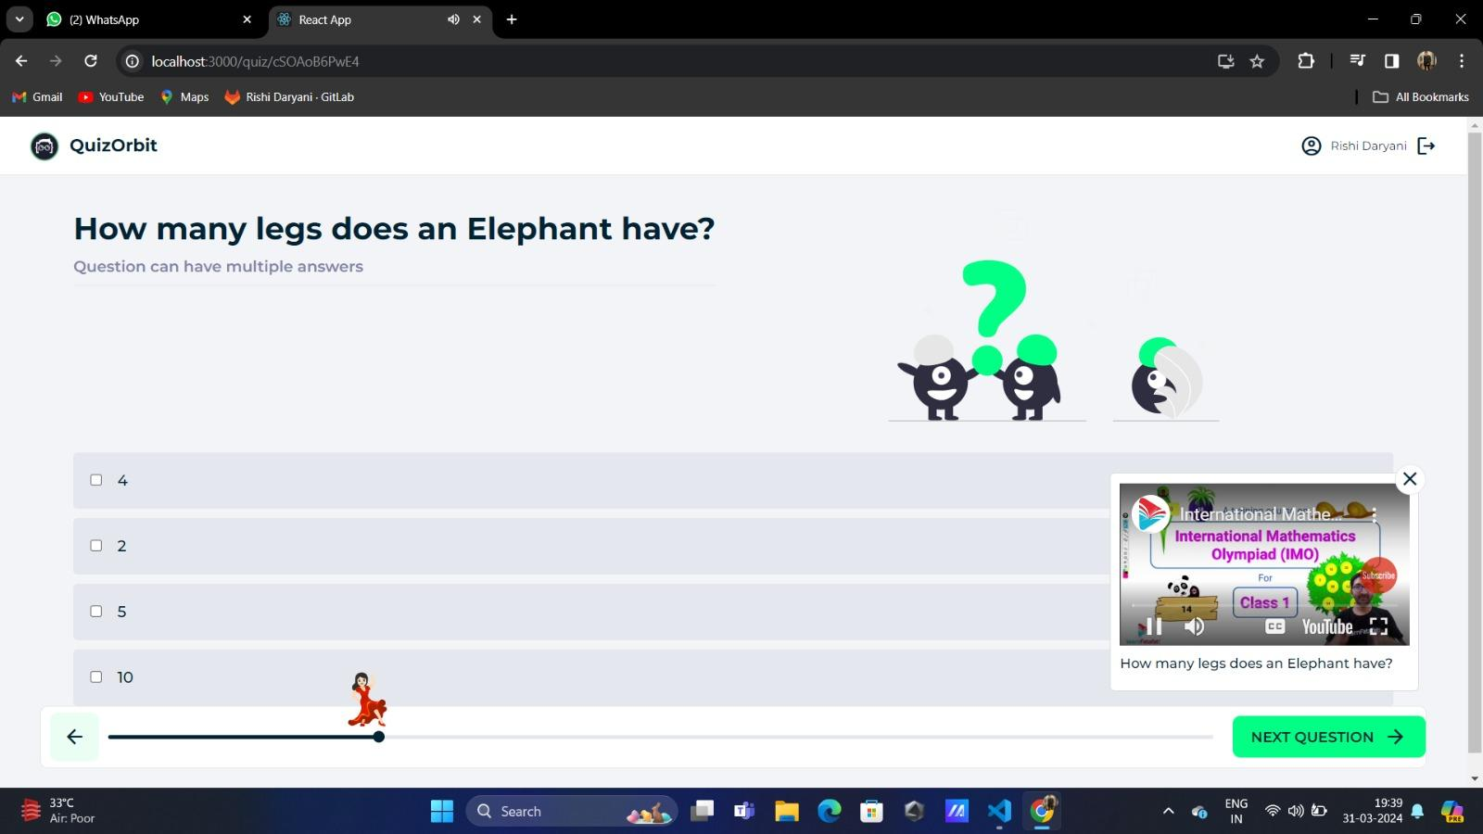

**Figure 3.5.3 -** Quiz with the progress bar and the mini player

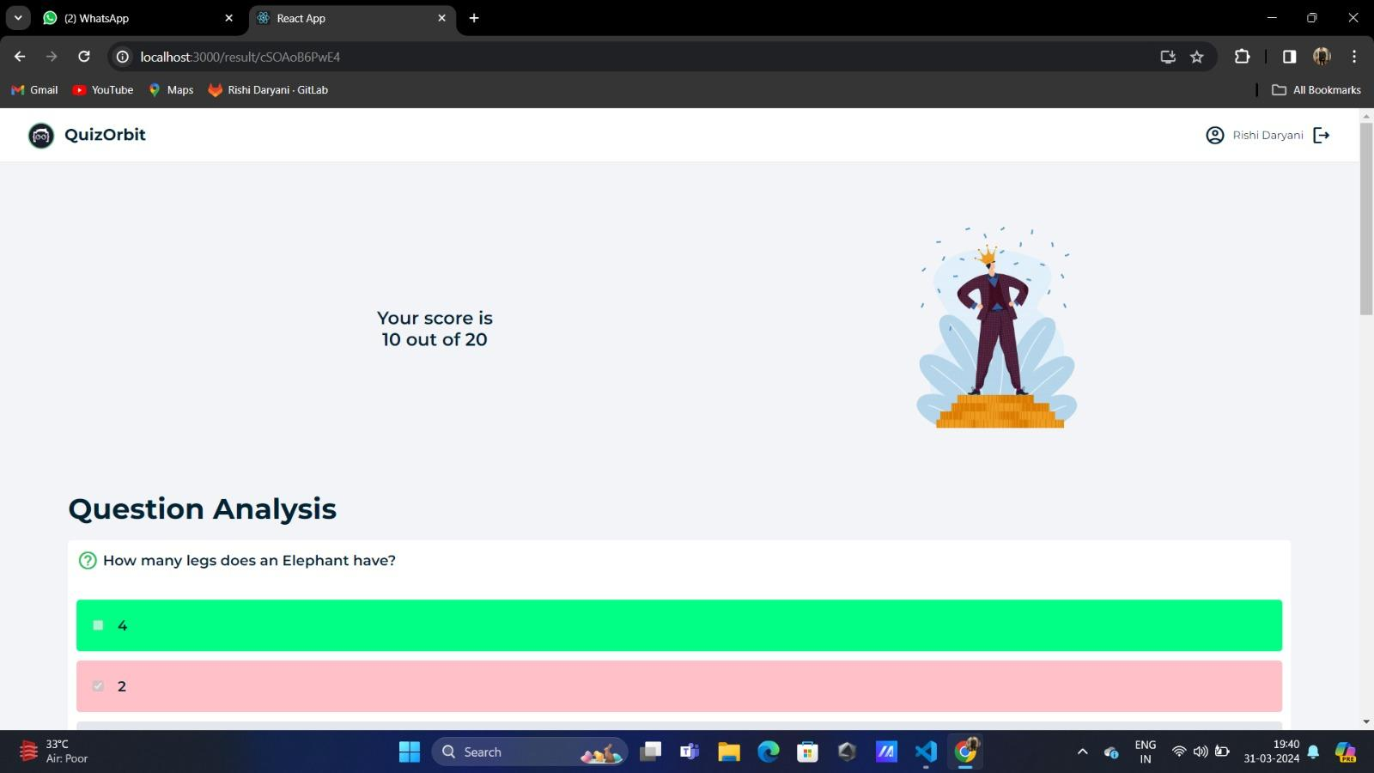

**Figure 3.5.4 -** The Score section after attempting the quiz

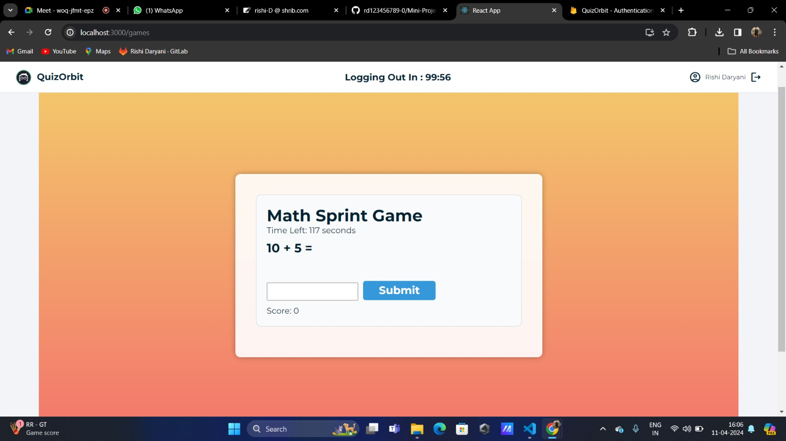

**Figure 3.5.5 -** The Math Sprint Game for entertainment purpose

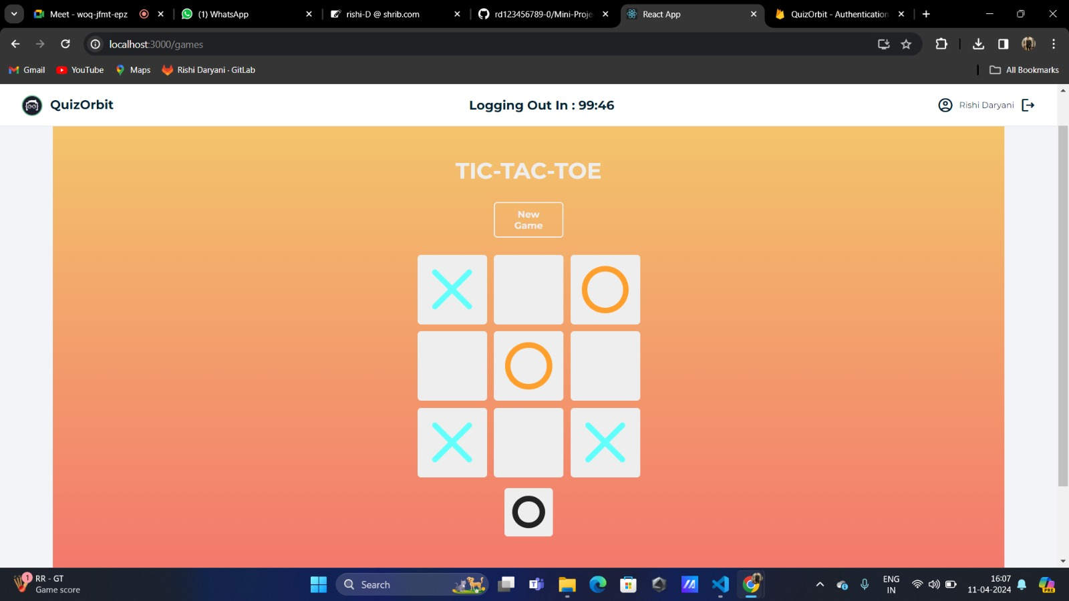

**Figure 3.5.6 -** TIC-TAC-TOE for entertainment purpose

**3.6 Conclusion and Future work:**

Developing a quiz based app can be a rewarding endeavor, as it can engage users, promote learning, and even serve as an effective marketing tool. User Engagement: Quiz apps are an excellent way to engage users and keep them interested in a particular subject or topic. By offering a variety of quizzes and challenges, the app can cater to different interests and knowledge levels.Learning and Education: Quiz apps can be a valuable educational tool. They encourage users to test and expand their knowledge, making learning more interactive and enjoyable.Marketing and Branding: For businesses, a quiz based app can be used to promote their brand, products, or services. Incorporating promotional quizzes or offering prizes can help boost brand recognition and customer User Analytics: Analytics are crucial for improving the app. Collecting data on user behavior, quiz performance.

**References :**

1. T. Vlad, D. Pitică and L. Man, "Smart education — A new approach for beginners in electronics," 2011 IEEE 17th International Symposium for Design and Technology in Electronic Packaging (SIITME), Timișoara, Romania, 2011, pp. 373378, doi: 10.1109/SIITME.2011.6102755.

2. W. Shi et al., "Review on Development of Smart Education," 2019 IEEE International Conference on Service Operations and Logistics, and Informatics (SOLI), Zhengzhou, China, 2019, pp. 157162, doi: 10.1109/SOLI48380.2019.8955052.

1. Existing websites

<https://www.olympiadsuccess.com>

[www.byjus.com](http://www.byjus.com)

<https://www.unacademy.com>

2. App https://play.google.com/store/apps/details?id=com.sof.revise&hl=en&gl=US&pli=1[SOF Olympiad app]

https://play.google.com/store/apps/details?id=com.unacademyapp&hl=en&pli=1 [Unacademy app]

https://play.google.com/store/apps/details?id=com.byjus.thelearningapp&hl=en&gl=US [Byju's app]